HAB Descent Model
Oct 10, 2026 · Nicole

Data used
The only usable past flight is PAC2023: SPOT tracker history on 17–18 Nov 2023, launched from Lancaster, PA. positions are estimated based on the graph location, so they are good to about ±2 km.
Input | Value | Status
Launch point | 40.047, −76.307 (Lancaster) | Estimated
Landing point | 39.683, −75.905 (just south of PA/MD line, near Rt 273) | Estimated
Flight date | 17–18 Nov 2023 | Exact time unknown
Winds aloft | IAD (Sterling, VA) radiosonde, 18 Nov 2023 12Z (7 am EST), 85 m–34 km | Real, but may not match flight time
Parachute | 30 in diameter, Cd 1.5 | Size real, Cd assumed
Payload box | 10 × 10 × 6.5 in, Cd 1.05 | Size real, Cd assumed
Payload mass | 1.5 kg | Assumed
Ascent rate / burst altitude | 5 m/s / 30 km | Assumed

Method
run the model on a past flight, then compare it with where that flight actually landed.
- Imports the descent physics from descent_V2.py as is.
- Swaps the placeholder wind_at() for the real IAD winds, interpolated by altitude.
- Adds a minimal ascent: the balloon rises at a constant rate and drifts with the wind until burst, then the descent code takes over.
Flight phases in the baseline run: about 100 min of ascent to 30 km, then 41 min of descent.
Because most inputs are guesses, I also re-ran it while changing one input at a time. The cases were burst altitude from 10 to 30 km, ascent rate 4 and 6 m/s, all winds halved, and only the winds below 2 km.Results
The baseline prediction lands at 40.239, −74.764, near Trenton, NJ. That is 115 km from where the balloon actually came down.
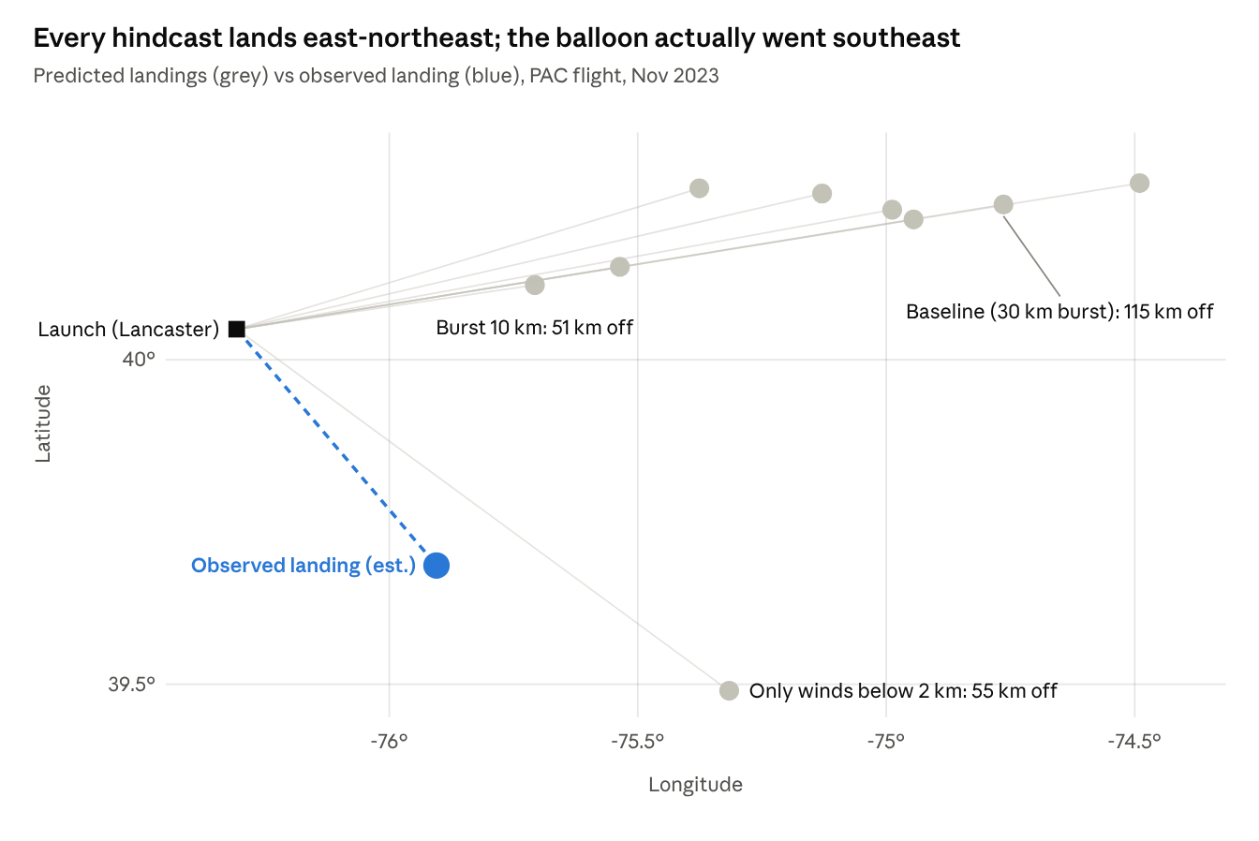
hindcast_2023.py output · IAD winds 18 Nov 2023 12Z · observed points read from tracker screenshots (±2 km)
The direction is wrong, not just the distance. All eight cases that use the full wind profile head east-northeast (bearing 73–81°). Only the case limited to winds below 2 km turns southeast (126°), and it overshoots to 105 km.
The main sources of error, from biggest to smallest:
- Wind timing. One balloon sounding at 7 am on 18 Nov. If the flight was on 17 Nov, or in the afternoon, the winds aloft could have been very different.
- Burst altitude. Each 5 km lower burst shortens the predicted drift by roughly 10–30 km.
- Single wind station. IAD is about 120 km from Lancaster, and its balloon drifts too.
- Assumed numbers. Payload mass, ascent rate and both drag coefficients are guesses.
- Observed points. The observed points were read off screenshots (±2 km), so they are small next to the other errors.

Areas to improve
In priority order. The first three need data from the team, not code changes.
# | Improvement | Data or work needed
1 | Know exactly when and how high it flew | Launch time, tracker CSV export (time, lat, lon, altitude) from the PAC tracker or SPOT
2 | Use winds from the flight time | Soundings before and after launch (00Z/12Z), or hourly GFS/ERA5 model winds
3 | Real inputs | Payload mass, balloon type, helium fill, measured burst altitude
4 | Better wind source | Average two nearby stations (IAD + OKX or WAL), or gridded data
5 | Test on more flights | Every past PAC flight with a tracker log
6 | Show uncertainty | Run many cases and draw a landing area, not a single point

Data I might need:
- What date and time did the Nov 2023 flight launch?
- Can we export the tracker data as CSV, with altitude if it was logged?
- What were the payload mass
- Are there other past flights with tracker logs?

